Table of Contents

List of Figures 3

List of Tables 3

1 Introduction 4

2 Occupancy Classification 5

3 Overview of the Facility 7

3.1 [zone_name] 7

3.1.1 Various Rooms of Interest 7

4 Overview of Commodities in the Facility 8

4.1 Classification of Commodities 8

5 General Fire Protection 9

5.1 Occupancy and Divisional Separation 9

5.1.1 Divisional Separation 9

5.1.2 Occupancy Separation 9

5.1.3 Separation Requirements 9

5.2 Automatic Fire Extinguishment System 10

5.3 Escape Routes 11

5.1 Emergency Routes 11

5.1.1 Emergency staircases 12

Doors along the escape route 12

5.1.2 Signage 13

5.1.3 Emergency Lighting 13

5.2 Fire Hose Reels 13

5.3 Fire Extinguishers 13

5.4 Fire Hydrants 13

5.4.1 Provision of Firewater 14

5.5 Fire detection and alarm systems 14

5.6 Smoke Ventilation 14

5.7 Electrical Requirements 15

6 Special Risks 16

6.1 Diesel Tank 16

6.2 Inverter Canopy 16

6.3 Idle Pallet Storage 16

6.4 Oil Tanks 17

6.4.1 Indoor Oil Tank 17

6.4.2 Outdoor Oil Tanks 17

6.1 Transformers 18

6.1.1 Fire Separation between the Transformers and the Building 18

6.1.2 Fire Separation between the Transformer and Adjacent Electrical Equipment 18

6.1.3 Fire Separation Between Transformers 19

6.1.4 Fire Protection of Transformers 19

7 Final Summary and Recommendations 20

# List of Figures

Figure 1: Occupancy classification according to fire load (extract of Table in SANS 10400-T) 5

Figure 2: Aerial View of Site from Google Maps 5

Figure 3:CAD Plan of Site 6

Figure 4: Photo of room 7

Figure 5: Proposed divisional separation 9

Figure 6: Fire alarm panel and fire alarm system zones. 14

Figure 7: Diesel tank outside the building 16

Figure 8: Inverter Cage 16

Figure 9: Pallet outdoor storage details according to FMDS 8-24 17

Figure 10: Wooden pallets stored indoors 17

Figure 11: Table 5 as per FM Global DS 5-4 18

# List of Tables

Table 1: Expected commodities, their respective category classification and maximum stacking height without an automatic sprinkler system. 8

Table 2: Categories and permitted stacking heights of commodities block stacked in the Snacks building. 10

# Introduction

[company_name] performed a Fire Compliance Assessment at [client_name], [town], [province]. The facility is used for [facility_process].

According to SANS 10400-A, section 4.5.2, buildings constructed before September 1, 1985, do not need to comply with the National Building Regulations Act (Gazette 9608 of 1 March 1985), and subsequently do not require occupancy certificates. However, buildings that were built or had additions or major internal changes and alterations after September 1, 1985, are required to comply with the National Buildings Regulation.

The [building_name] building was constructed at [construction_year] therefore, it is required to comply with the National Buildings Regulation. SANS 10400-T, 2024 Edition will be used as the basis for the fire compliance assessment.

This assessment will address the [building_name] building, focusing on identifying hazards and recommending measures to achieve fire safety standards.

The fire compliance assessment was to determine if the site complied with the National Building Regulations (Act No. 103 of 1977) in terms of, what was referenced in the report

* SANS 10400-A - 2022 Edition, General Application
* SANS 10400-T - The application of the National Building Regulations: Fire Protection
* SANS 10400-S - The application of the National Building Regulations: Facilities for People with Disabilities
* SANS 10400-M - The application of the National Building Regulations: Stairways
* SANS 10400-W - 2011 Edition, Fire Installation
* SANS 1186-5 - Symbolic safety signs: Part 5: Photoluminescent signs
* SANS 10287 - Automatic sprinkler installations for fire-fighting purposes
* SANS 10131 – Above-ground storage tanks for petroleum products
* SANS 10251-1 – Water supply and drainage for buildings
* FM Global Datasheet 8-24 – Idle pallet storage

# Occupancy Classification

The [building_name] building is a [description] facility ([classification]).

The [building_name] building is constructed from [construction_materials] lower walls and [construction_materials] sheeting upper walls and ceiling.

The occupancy classification of a building is usually determined by considering the processes that the building is used for according to SANS 10400-A, 2022. For the purposes of fire protection, the factor used to determine occupancy classification is fire load as per SANS 10400-T, Table 2 (in most cases SANS 10400-A and SANS 10400-T will classify occupancies similarly).

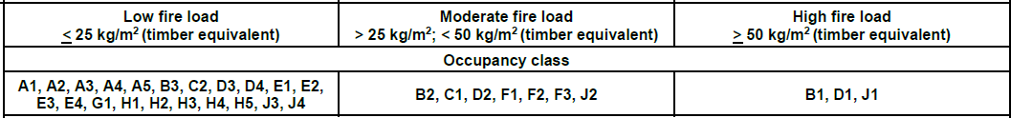

Figure : Occupancy classification according to fire load (extract of Table in SANS 10400-T)

The existing approved fire protection plans indicate that the plan was submitted with the building classified as a [classification_description], [building_classification], occupancy. According to the table above, a building can be classified as a [building_classification] occupancy warehouse if the fire load is less than an equivalent 25kg of timber per m2 of floor area.

Canola oil has a calorific value of 44MJ/kg, which is equal to 2.44 times the 18MJ/kg calorific value of wood.

Due to the significant quantities of oil and stacked finished goods (chips/popcorn in plasticised aluminium bags in boxes and flat packed card boxes), stored in the facility, for the purposes of this report, the building will be classified as a moderate risk, [building_classification], occupancy. A fire load calculation can be carried out to determine if the occupancy need not be changed from [building_classification] to [building_classification], upon request of [company_name].

The total building area is [total_building_area] m2.

[aerial_view]

Figure : Aerial View of Site from Google Maps

[cad_drawing]

Figure :CAD Plan of Site

# Overview of the Facility

The facility is divided into multiple areas where different processes take place. Each area poses different risks dependant on the activities and commodities in the area.

## [zone_name]

### Various Rooms of Interest

[zone_description].

[zone_photo]

Figure : Photo of room

# Overview of Commodities in the Facility

The [building_name] is used as a [facility_process] and [facility_process] facility to [building_description].

## Classification of Commodities

The main facility is divided into different processing and ancillary storage areas. The classification of the commodities, according to SANS 10287, is used to determine the classification of the commodities.

Table : Expected commodities, their respective category classification and maximum allowable stacking height without an automatic sprinkler system.

|  |  |  |
| --- | --- | --- |
| **Expected Commodity** | **Category** | **Maximum allowable stacking height for block stacking or free-standing storage (m)** |
| [commodity_name] ([storage_type]) | [category] | [stacking_height] |
| Plasticised aluminium rolls | III | 3.0 |
| Canola oil | IV | 1.2 |
| Lightweight cardboard (flat stacked) | II | 3.0 |
| Potatoes (vegetable) | I | 4.0 |
| Maize seeds (in HDPE bags) | II | 3.0 |
| Spices | II | 3.0 |

1. Finished goods in boxes refers to packaged potato chips and/or popcorn.

Product storage needs to be managed and maximum stacking heights adhered to. Stacked goods are discussed further in section 5.2.

# General Fire Protection

## Occupancy and Divisional Separation

### Divisional Separation

According to SANS 10400-T, Table 3, any occupancy classified as a D2 with a single fire division larger than 2500 m2 requires an automatic fire extinguishment system. Due to the size of the building fire division separating elements will need to be constructed to ensure all divisions are less than 2500 m2 or a sprinkler system must be installed.

### Occupancy Separation

Occupancy separation is required between different occupancies. Occupancy separation is not required in sprinkler protected areas. Therefore, no separation is required between the [building_name] ([building_classification]) and [building_name] ([building_classification]). Separation is required between the [building_name] ([building_classification]) areas and the rest of the facility.

### Separation Requirements

To create fire separations, fire rated elements (fire walls, doors etc.) are used. For the separation to be effective, the fire rating of these elements should not be compromised. Therefore, fire walls should extend to roof level and any penetrations through fire walls require fire stopping.

Separation is required between:

* The [building_name] and the [building_name] facility to achieve divisional separation. This will be achieved with 60-minute fire-rated elements as per SANS 10400-T.
* [building_name] and [building_name] to achieve divisional separation. This will be achieved with 60-minute fire-rated elements as per SANS 10400-T.
* The factories and the [zone_name] rooms to achieve divisional separation. This will be achieved with 60-minute fire-rated elements as per SANS 10400-T.

Figure : Proposed divisional separation

The locations of proposed separation elements are shown in the image above. These locations make use of existing brick walls, where they are available. Where brick walls are not available, separation elements are proposed where walls already exist to prevent disruption to existing activities or where walls can be built over the shortest distance. Where [building_materials] walls already exist, any openings in those walls will need to be fire rated by being closed with brick-and-mortar, being replaced with (equivalent) fire rate elements, or being equipped with cut-off sprinklers.

Class A fire rated doors and fire rated shutters are required along 60-minute fire separations for divisional separation. Fire doors in high traffic areas are to be equipped with automatic self-closing devices and set to normally open positions by means of electromagnetic locks that release in the event of a fire.

Any penetrations or openings in fire walls will require fire stopping. This can be achieved by filling the void in the wall with the appropriate fire rated board, fire rated silicon and painting over that with intumescent paint. Specialised fire collars can also be used.

The combustible electrical cabling through the fire walls will also be required to be coated with intumescent paint. The cables should be coated for a minimum of one metre on both sides of the penetrations.

## Automatic Fire Extinguishment System

The classification of the commodities, according to SANS 10287, Table 2, is used to determine the hazard classification of the commodities.

When the maximum permitted stacking heights of commodities is exceeded, the building housing the commodities is required to have automatic sprinkler protection. Stacking heights are dependent on the hazard classification as well as the type of storage. Table 2 is a summary of all the stacked commodities, their respective hazard classification and the maximum allowed stacking height depending on the type of storage used, without an automatic sprinkler system.

Table : Categories and permitted stacking heights of commodities block stacked in the [building_name] building.

|  |  |  |  |  |  |
| --- | --- | --- | --- | --- | --- |
| **Area** | **Commodity** | **Category** | **Type of Storage** | **Maximum Allowed Stacking Height (m)** | **Current Stacking Height AFFLa (m)** |
| [zone_name] | [commodity_name] | [commodity_category] | [commodity_storage_type] | [commodity_stacking_height] | [auto_extinhuishment_max_stacking_height] |
| Cardboard boxes (flat stacked) | II | Block stacking | 3.0 | 1.4 |
| Factory 2 | Finished goods* (in boxes) | II | Block stacking | 3.0 | 2.8 |

1. Above finished floor level (AFFL).
2. Finished goods in boxes refers to packaged potato chips and/or popcorn.

If the stacking heights in Table 1 are not adhered to, in conjunction with fire separations described in Section 4.1 then an automatic fire extinguishment system will be required to be installed.

## Escape Routes

Escape routes have been designed in the approved fire plans. Escape routes shall be marked according to the approved general fire protection plans.

Escape signage must be installed as indicated by the approved fire plans. Signage may be of the photoluminescent type and shall comply with the relevant requirements of SANS 1186-5 as per the approved fire protection plan. All signage needs to mechanically mounted.

Every locking device fitted to an access door or escape door in any escape route shall be of a type approved by the local authority, provided that in any building where an electronic locking device is required for security purposes, such locking device shall be of a type which unlocks automatically when any of the fire detection equipment or electrical fire protection equipment of the building is activated or when there is no power to the locking device.

## Emergency Routes

From some areas, the travel distance to the nearest escape door is more than 45 metres. [no_of_escape_routes] escape routes have been provided and an emergency route forms part of each escape route. The travel distance measured to the nearest access door or escape door is not more than 45 m and the path of travel to access doors and escape doors is along a feeder route.

Emergency routes have been designed to ensure that occupants can evacuate the building. They will be marked according to the general fire protection plans. The number of emergency routes as shown on the fire plan is in line with the building regulations to comply with deemed to satisfy requirements.

The minimum width of the emergency routes on the ground and first floor are to be 1100 mm for a population less than and equal to 120 persons on each floor. Emergency routes are provided, throughout their length, with a clear vertical headroom of 2 metres and in any lobby, foyer or vestibule the minimum room height is not less than 2,4 metres.

Any dead-end corridor shall not be allowed to exceed 10 m in length anywhere in this facility. A corridor where the dead-end length "A" is less than 2.5 × the width should not be considered a dead-end corridor.

All escapes shall be sized, sited, and provided with the appropriate means to accommodate and safely discharge the expected number of occupants safely from the building.

### Emergency staircases

The staircases located along the emergency route are designed in line with the requirements for staircases given in SANS 10400-M. The width of a stairway that forms part of an escape route shall be not less than 1.1 m as per SANS 10400-T, table 12.

Where a stairway forms part of an emergency route, such stairway shall, throughout its length, be provided with a handrail on either side in accordance with the requirements of SANS 10400-S. Any handrail may project into such width by an amount of not more than 100 mm.

The distance between any change in floor level and the centre line of a doorway in an emergency route or between two changes of floor level in such route shall be not less than 1,5 m. The emergency staircase is provided with windows not less than 1 m2 in area for natural ventilation to the outside of the building at each storey level.

The enclosed or external stairways that form part of an emergency route discharge at ground level directly into an open leading to a street or public place. Refuges are provided, in accordance with the requirements of SANS 10400-T, section 4.16.8, at a rate of not less than one per storey and a fire resistance of no less than 30 minutes.

### Doors along the escape route

Every locking device fitted to an access door or escape door in any escape route shall be of a type approved by the local authority, provided that in any building where an electronic locking device is required for security purposes, such locking device shall be of a type which unlocks automatically when any of the fire detection equipment or electrical fire protection equipment of the building is activated or when there is no power to the locking device. The storage of keys in break glass boxes are not permitted.

### Signage

Escape signage throughout the facility is not sufficient and additional escape signage must be installed as indicated by the approved fire plans. Signage may be of the internally or externally illuminated, or photoluminescent type and shall comply with the relevant requirements of SANS 1186-1, SANS 1186-3, SANS 1186-5, and SANS 1464-22. All signage needs to mechanically mounted. Signage will direct occupants from all common and open plan areas to the nearest escape and firefighting equipment.

### Emergency Lighting

For all floors, their fire escape routes and fire equipment positions, an emergency lighting system with a power supply independent of the normal mains will be provided. The system will be capable of operating for not less than 60 minutes in the event of failure of the mains supply, shall be equipped to these areas as per the electrical engineer.

## Fire Hose Reels

According to SANS 10400-T, a fire hose reel is required for every 500 m2 of floor area or part thereof, in buildings larger than 250 m2. Therefore, a minimum of ten fire hose reels should be installed to cover the entire site. Furthermore, all areas must be within the 30-meter reach of a fire hose reel, as stipulated by SANS 10400-T.

[no_of_fire_hose_reels] fire hose reels have been provided as per the approved fire protection plans.

## Fire Extinguishers

The fire extinguishers currently in use on-site are 9kg [fire_extinguisher_type] extinguishers. According to SANS 10400- T, Table 15, 9kg DCP or 10kg CO2 fire extinguishers must be provided at a rate of one per 100 m2 for [building_classification] areas. Therefore, a minimum of 46 fire extinguishers must be provided for the entire building.

Only [no_of_fire_extinguishers] 9kg DCP extinguishers are indicated on the approved fire protection plans. Additional fire extinguishers must be provided.

## Fire Hydrants

According to SANS 10400-T, section 4.35, one fire hydrant is required for every 1000 m2 or part thereof of total floor area. Thus, the building requires at least [no_of_fire_hydrants] hydrants. Each hydrant must be positioned so that no part of the building is more than 90 meters from a hydrant, and no access door is more than 70 meters away.

The positions of [no_of_fire_hydrants] hydrants are indicated on the approved fire protection plans.

### Provision of Firewater

The provision of firewater is dependent on the number of hydrants that come into operation simultaneously in any division. Since there are no fire divisions in the building, the entire floor area is taken into consideration. The building has an area of [building_area]m2. Thus, three hydrants area required to operate simultaneously.

A hydraulic model will need to be compiled to evaluate the required fire water. Each hydrant will require a minimum flow pressure and flow rate of 300 kPa and 1 200 litres per minute respectively as per SANS 10251-1, section 7.2.2. A flow and pressure test will be required to verify if the municipal supply is sufficient or if fire water tanks and pump are required. The results of the hydraulic model will be used to determine sufficient tank and pump capacity on site. Firewater tanks are required to be steel tanks with sufficient water for 60 minutes of firefighting.

## Fire detection and alarm systems

Fire detection systems, manual call points, and visual-audible alarm beacons must be installed in all [building_classification] areas as specified in SANS 10400-T, Table 14. All fire detection and alarm systems are to be designed and installed in accordance with SANS 10139.

[detection_system_type] fire detection system is required for the protection of life and property. The system is to offer the earliest possible warning of fire, to achieve the longest available time for escape and to minimize the time between ignition and the arrival of fire-fighters.

[fire_alarm_panel_photo]

Figure : Fire alarm panel and fire alarm system zones.

## Smoke Ventilation

Natural or mechanical smoke ventilation is required within any room with a floor area larger than 500m2. Smoke ventilation must be designed and installed according to SANS 10400-T, section 4.42.

The building is equipped with smoke ventilation. The smoke design should be on file at the building control offices otherwise a smoke calculation is required to determine if the existing smoke ventilation is sufficient.

## Electrical Requirements

To mitigate the risk of electrical fires all cooling system fans, heating elements, air conditioning fans and electrical control boards must be fitted with earth leakage, thermal and overload protection. All certificates of compliance must be in place and up to date.

It is recommended to install localized gas suppression in all main distribution and control boards throughout the site.

# Special Risks

## Diesel Tank

One [tank_capacity] litre diesel tank is located outside the building. The tank is located more than 1.5 metres away from the building. This is above the required safety distance of 1.5 metres (SANS 10131, Table 2). The tank requires:

* a minimum of 1.5 metres between the tank and the inside toe of the bund wall. This must be corrected.
* an oil separation sump
* signage indicating the tank capacity
* an emergency shut-off valve for the dispenser.
* drain that goes into a closed, oil separating sump for the dispensing area.

Fire plans must be drafted and submitted to the local fire department for approval for the Diesel tanks and dispensers.

[diesel_tank_photo]

Figure : Diesel tank outside the building

## Inverter Canopy

The inverters are located outside the building in a well-ventilated area. The adjacent building wall is made of [building_material], providing sufficient fire protection between the building and inverter area. The inverter area requires an emergency cutoff switch in an accessible location, outside the fenced area and a 10kg CO2 fire extinguisher. The extinguisher can be on a trolley or wall mounted.

[inverter_image]

Figure : Inverter Cage

## Idle Pallet Storage

Wooden idle pallets are stored in the [zone_name]. These must be stored outside. Idle pallet storage must be located at least 15 metres from any building, or a firewall must be constructed as per the requirements of Table 1 below. The required distance between the firewall and the Idle pallet storage is based on the rating of the firewall and the number of pallets stored as per FM DS 8-24. The table below summarises the requirements for firewalls.

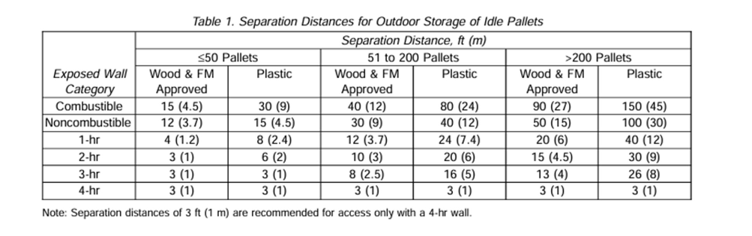

Figure : Pallet outdoor storage details according to FMDS 8-24

[pallet_storage_photo]

Figure : Wooden pallets stored indoors

## Oil Tanks

For operations where Class II or Class III liquids (FP ≥ 37.8°C) are stored in atmospheric tanks or transferred at temperatures below their flash points, fire and explosion hazards need not be addressed.

Canola oil has a flash point of 260°C. The oil on site is stored and transferred at temperatures below 93.3°C therefore, no fire and explosion hazards need not be addressed.

### Indoor Oil Tank

The indoor oil tank is in [zone_name] near the oil fryers. The tank must be equipped with bunding that can contain 110% of the oil tank capacity.

### Outdoor Oil Tanks

[no_of_outdoor_oil_tank] outdoor oil tanks are in a bunded area adjacent to the building. [no_of_outdoor_oil_tank] tanks have an oil capacity of [oil_tank_capacity] litres and the [oil_tank] is a [oil_tank_capacity] litre tank.

In accordance with SANS 10131, section 4.3.2.1, the tanks require a separation distance that is a sixth the sum of their diameters but not less than one metre. If each of the tanks has a diameter below 2 metres, the separation distance required will be 1 metre.

The total volume of oil is below [oil_volume] m3, therefore the oil storage is not classified bulk oil storage. The safety distance required between the building and a tank, for individual tanks with a capacity below 48 000 litres, is 1.5 metres as per Table 3 of SANS 10131. The minimum distance between a tank and the toe of the inside of a bund wall should be at least 1,5 m.

Based on the design of the existing bund, the safety distance requirements are not being met. Additional fire protection is required. A fire protection system with foam bund borders should be designed and installed. The adjacent building wall is not a full brick-and-mortar wall, the fire rated separation needs to be extended to roof level.

## Transformers

[no_of_transformers] transformers with non- FM approved oils are located adjacent to the building. The transformers have oil capacities of [transformer_oil_capacity] and [transformer_oil_capacity] litres respectively.

### Fire Separation between the Transformers and the Building

The walls of the main building are constructed from [building_materials] walls. These walls provide a fire rating of 120-minutes.

As per the requirements of FM Global DS 5-4, table 5, the required minimum safety distance between transformer with less than 1900 litres (1.9 m3) of non-approved oil and the adjacent building is 1.5 metres.

*windows

### Fire Separation between the Transformer and Adjacent Electrical Equipment

As per the requirements of FM Global DS 5-4, table 5, the required minimum safety distance between transformer with less than 1900 litres (1.9 m3) of non-approved oil and adjacent critical equipment is 4.6 metres.

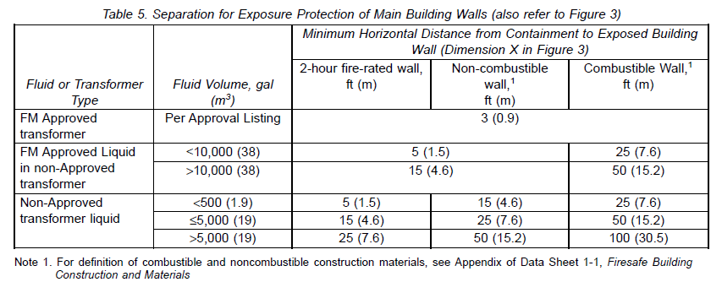

Figure : Table 5 as per FM Global DS 5-4

According to FM Global Data Sheet 5-4, Transformers, separation is required between transformers and the generator switchgear. The switchgear is stored in a metal enclosure. This can be classified as non-combustible wall. The required separation distance between the transformer and the switchgear is 4.6 metres. The separation distance is below 4.6 metres therefore a two-hour fire rated wall should be erected between them. The fire wall must be at least 600mm away from the transformer components and it should extend to roof level (use of solid brick wall, reinforced concrete construction or fire-rated drywall is preferred).

The distance between the transformers and the generator is [transformer_generator_distance] metres which provides adequate separation. combustible

### Fire Separation Between Transformers

As per the requirements of FM Global DS 5-4, table 8, the required minimum safety distance between transformers with less than 1900 litres (1.9 m3) of non-approved oil is 1.5 metres.

The minimum safety distance between transformer is not met therefore, a two-hour fire rated wall should be erected between them. The fire wall must be at least 600mm away from the transformer components and it should extend to roof level (use of solid brick wall, reinforced concrete construction or fire-rated drywall is preferred).

Alternatively, water spray protection should be installed on each transformer in accordance with FM Global DS 5-4, section 2.3.2.

There is a deluge system installed on each of the transformers currently, however, they are incorrectly installed.

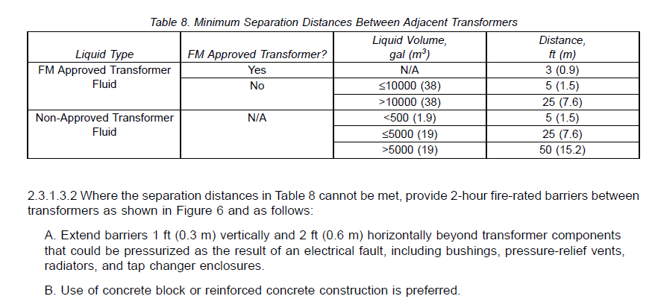

### Fire Protection of Transformers

Bunding is necessary around the transformers to contain any potential spills or leaks that might occur. Bunding should be constructed to contain 110% of the oil capacity of the transformer.

# Final Summary and Recommendations

To address identified fire risks and ensure compliance with SANS 10400-T and other relevant standards, implement the following mitigation strategies:

* Adhere to stacking height limitations to avoid the need for an automatic fire extinguishment system.
* Create adequate fire separation to avoid the need for an automatic fire extinguishment system.
* Fire-rated walls and doors must be used to separate areas with different occupancies and to create sufficient division areas.
* Firestop any fire wall penetrations using fire-rated boards, fire-rated silicon, and intumescent paint. Any combustible elements that penetrate fire-rated walls must be coated with intumescent paint for a 1-meter on either side of wall penetrations.
* Adhere to escape routes as per approved fire protection plan.
* Ensure fire hose reels are mounted in accordance with the approved fire protection plan.
* Provide enough fire extinguishers (DCP and CO2) throughout the site, ensuring compliance with SANS 10400-T standards for floor area coverage.
* Five fire hydrants and steel firewater tanks with sufficient capacity for 60 minutes of firefighting must be installed, ensuring adequate water supply during fire emergencies.
* A pump capable of supplying a source duty for three hydrants operating at 3600 L/min at 3 bars must be provided.
* Mechanical or natural smoke ventilation systems to be evaluated ensuring compliance with SANS 10400-T.
* L1/P1 fire detection system must be provided for the facility.
* Pallet storage must be either located 15 meters away from buildings or separated by fire walls to prevent fire spread.
* 10kg CO2 fire extinguisher and emergency cut-off switch to be placed in the inverter area.
* The indoor oil tank must be bunded with a bund that can hold 110% of the capacity of the tank.
* The outdoor oil tanks must be separated with a minimum distance of one metre between them.
* Additional fire protection is required for the outdoor oil tanks.

The following strategies are not requirements; however, they are recommended for sufficient risk mitigation:

* Localized gas suppression for main distribution and control boxes.
* Both In2Foods Benoni buildings to be supplied with fire water from the same set of tanks and pumps (if required).

To ensure ongoing adherence to SANS codes, including SANS 10400-T, SANS 10400-S, SANS 10400-M, and others, to maintain fire safety and regulatory compliance throughout the facility, deemed to satisfy (DTS) fire plans must be drafted and signed off by an ECSA registered fire engineer.

**Compiled by:**

**[engineer_name]**

**[engineer_position]**

**Reviewed by: Approved by:**

**[engineer_name] [engineer_name]**

**[engineer_position] [engineer_position]**

**[ecsa_category] (ECSA [ecsa_id]) [ecsa_category] (ECSA [ecsa_id])**